Type.ai Functionality Analysis

Main Function : Chat
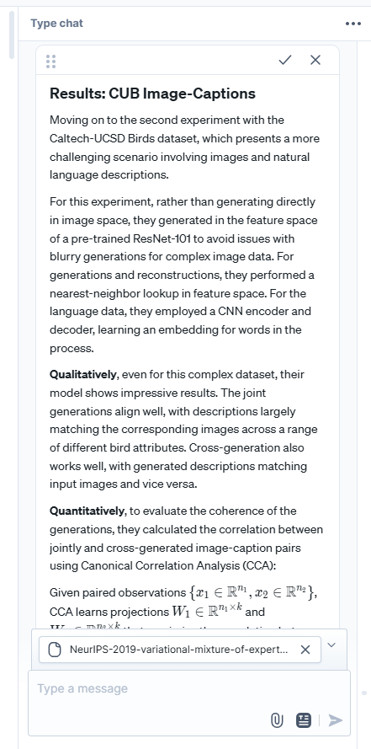

All test windows have the following options left to right:
- Text Block drag and drop
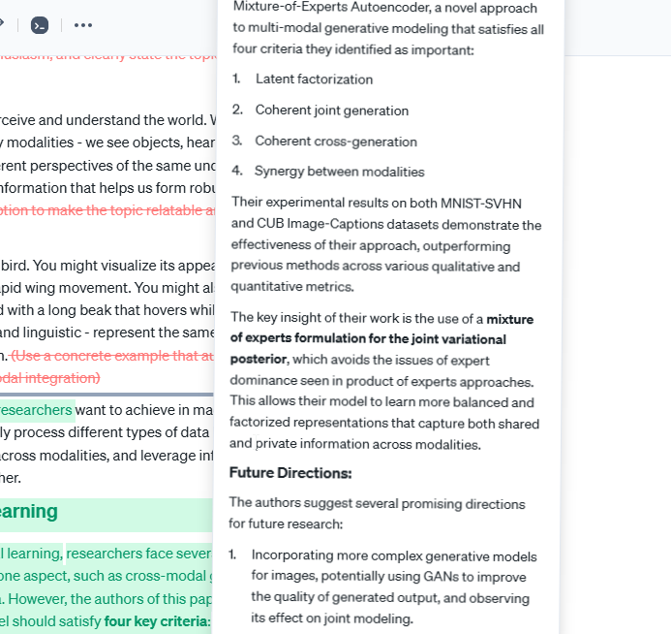
Takes the entire response as block and can insert into the text

- Apply to text
Same as windsurf/cursor, highlights changes for approval.
This process unlike windsurf/cursor takes a bit of time, I would assume its that its not actually interacting with the existing text, but rather running a comparison prompt.
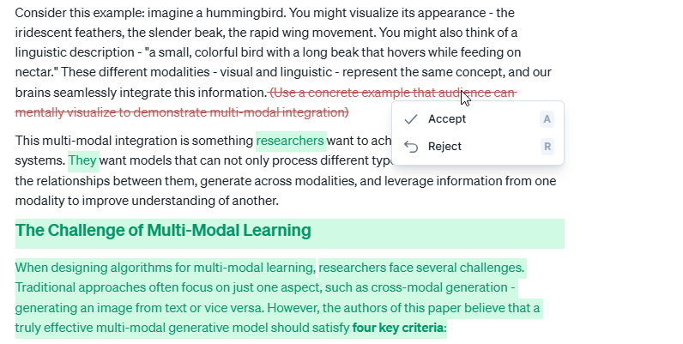
- Insert text at cursor or replace selection
Manually do what the second option is supposed to automatically do, thus assuming the second option is unreliable

- Copy to clipboard

Known Issues
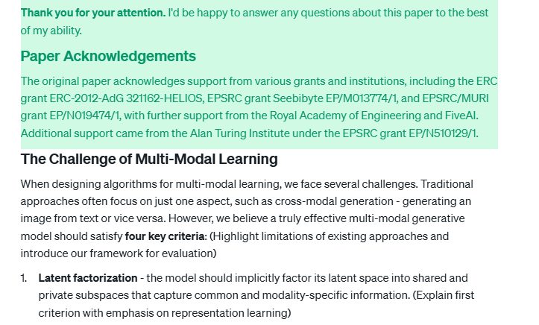
Major reasoning flaw.
As seen in this case, when I wanted to edit the text without any specific line given using the prompt “include more of the formulas from the file” for the script of a presentation, it regenerated an entire script and placed it in the middle of my existing file. In the image one can see that the conclusion is reached before another undiscussed topic is mentioned from the previous text.

Possible Reasons:
- Context window did not allow the whole text to be sent as prompt
- Consecutive prompts are not closely connected
- Prompt engineering mistake

From this one can also with relative assurance say that the auto insert is often not working, as it did not compare my previous text to my existing one, making changes to where context overlaps, but instead just dumped a large part of the response into the file.

Bad Memory
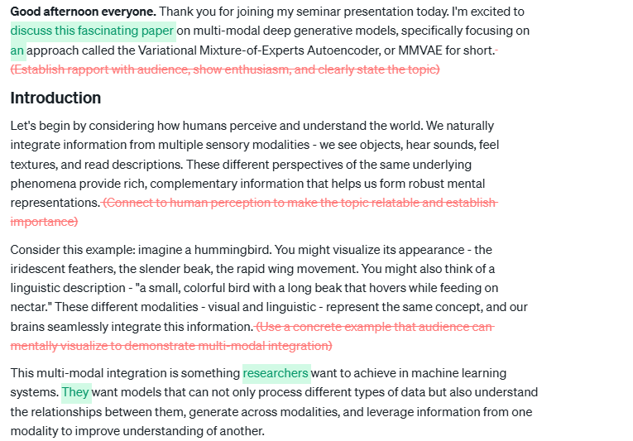
In a previous prompt, I asked the AI to put in brackets the intention and meanings I would like to convey with this particular paragraph. However, during the next prompt, the AI wanted to remove these previous changes as they did not fit the new prompt, even though i never mentioned to remove them.

Issues with local editing

In windsurf/cursor, we can do local editing by selecting a section of code to change it. However in type, the result is as follows:
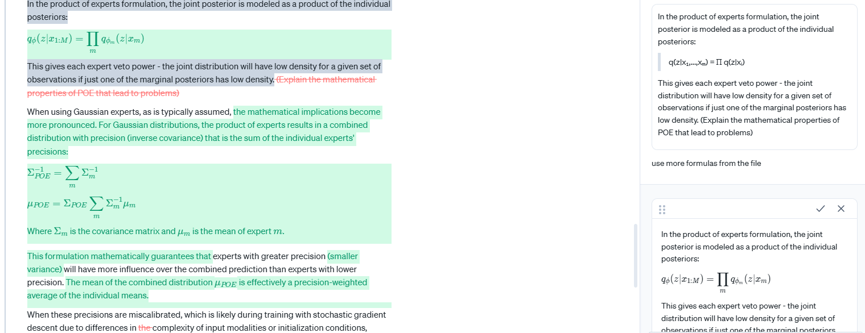
The grey area is the highlighted area, but the AI generated beyond the intended scope.

